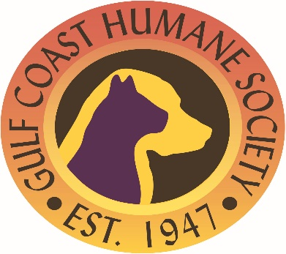

**Job Description**

# Job Title: Animal Care Supervisor

**Department:** Shelter

**Classification:** Full-time, non-exempt

**Job Relationship:** Reports to Operations Manager

**Position Summary:** The Animal Care Supervisor plays a critical role in ensuring the well-being of the animals under our care. This position oversees daily operations in the animal care areas, manages a team of animal care staff, and ensures that all animals receive high-quality care in a safe and sanitary environment. The ideal candidate will have strong leadership skills, a deep understanding of animal care, and a passion for advancing the mission of GCHS.

**Essential Job Functions:**

* Lead, mentor, and support a team of animal care staff and volunteers.
* Schedule and coordinate staff shifts to ensure adequate coverage.
* Conduct performance evaluations and provide ongoing training and professional development for team members.
* Oversee daily care routines for all animals, including feeding, grooming, and medical treatments.
* Monitor and maintain the health and behavior of animals, identifying and addressing any signs of illness or distress.
* Ensure that animal living areas are clean, safe, and properly maintained.
* Implement and enforce sanitation protocols and health standards.
* Coordinate with maintenance staff to address any facility issues or repairs.
* Maintain accurate records of animal care, medical treatments, and adoption information.
* Assist with the intake and adoption process, including animal assessments and consultations with potential adopters.
* Collaborate with the management team to develop and implement policies and procedures.
* Promote GCHS programs and services to the community.
* Participate in outreach events and educational programs as needed.
* Build and maintain positive relationships with donors, volunteers, and community partners.
* Other duties as assigned

**Qualifications:**

* High School Diploma or GED required; Associate’s or Bachelor’s degree in Animal Science, Veterinary Technology, or related field preferred.
* Minimum of 3-5 years of experience in animal care, with at least 1 year in a supervisory or management role.
* Strong knowledge of animal behavior, health, and welfare.
* Excellent leadership, organizational, and communication skills.
* Ability to work effectively under pressure and in a fast-paced environment.
* Proficiency in Microsoft Office and animal management software.
* Commitment to the mission and values of the Gulf Coast Humane Society.
* Ability to lift and carry up to 50 pounds.
* Capability to handle animals of varying sizes and temperaments.
* Comfort with working in various weather conditions and environments.

**Knowledge and Skills:**

* Advanced knowledge of cat and dog care with identification of breeds
* Advanced handling methods and knowledge of animal housing sanitation
* Disease knowledge and identification
* Kennel/animal experience required
* Proactive, positive attitude

**Time Commitments / Expectations**

* 40 Hours per week
* Must be available to work weekends and evenings

**Working Conditions**

Work is performed constantly in an animal shelter that operates seven days per week with exposure to animals, including some with questionable health and temperament concerns, high noise levels, zoonotic diseases, and cleaning agents. The person in this position needs to regularly move about the shelter to provide care to shelter and clients’ animals. Regularly operates a computer and other office equipment (i.e. calculator, copier, and printer). Occasionally positions self to handle animals of all sizes in a variety of areas and positions (low cages, high cages, on tables, on the floor, in vehicles, etc.). Constantly communicates with clients, staff members and volunteers who have inquiries and must be able to exchange accurate information in these situations. Occasionally moves animals weighing up to 50 pounds (i.e. through the shelter on leash or using other safe restraint and animal handling equipment, into and out of cages in the shelter, onto and off of exam tables)

**All GCHS employees are aware of the 5 Freedoms for Animal Welfare:**

* Freedom from hunger and thirst by ready access to fresh water and diet to maintain health and vigor
* Freedom from discomfort by providing an appropriate environment including shelter and a comfortable resting area
* Freedom from pain, injury, or disease by prevention or rapid diagnosis and treatment
* Freedom to express normal behavior by providing sufficient space, proper facilities, and company of the animal’s own kind
* Freedom from fear and distress by ensuring conditions and treatment which avoid mental suffering

Employee signature: _____________________________________________________

Date: _______________________________________